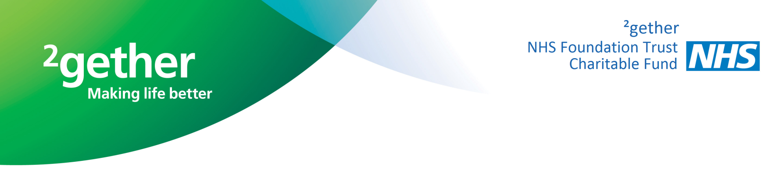
Fundraising Application Form
In support of ____________________________________
(please state name of site, team or department)
Please let us know about your proposed event/ activity:
Name of event/ activity:
Venue: of event/activity:
Date: of event/activity:
Expected income: | £
Net profit: | £
No. of participants:
Ticket price: | £
Licence required: | Y / N
Expected expenditure: | £

Details of the proposed event/activity:
I agree that money raised by me will be given to ²gether NHS Foundation Trust Charitable Fund
Your details:
Name:
Address:
Postcode:
Telephone Number:
Email Address:

Please note that our Charity Registration No 1097529 must be quoted on all correspondence, posters, tickets etc. Proofs of tickets, posters and adverts must be signed off by ²gether NHS Foundation Trust Charitable Fund before going to print. Anyone undertaking unofficial fundraising activities without the permission or knowledge of the Financial Accounts Department could be subject to criminal action.
Conditions: ²gether NHS Foundation Trust cannot be held responsible for loss or damage to personal effects, personal injury, public liability or for expenses related to this event. I have read and agree to the above conditions:
SIGNED: _____________________ DATE: ____________
Please tick I f you would not like to receive further information about fundraising
at ²gether NHS Foundation Trust Charitable Fund
FUNDRAISING AGREEMENT

Thank you for registering to raise money for ²gether NHS Foundation Trust Charitable Fund. As you will be collecting money from the public in support of ²gether NHS Foundation Trust Charitable Fund, we are required by law to have a written agreement with you.

It is important that you sign and return this copy to us before starting you fundraising. The Trust will acknowledge this application and issue you with a Fundraising Approval Number as evidence that we approve your fundraising idea.

I agree that I will:
- Only use sponsorship forms issued by ²gether NHS Foundation Trust Charitable Fund and not use any other type of sponsorship form (unless otherwise agreed with ²gether NHS Foundation Trust Charitable Fund).
- Only raise funds by carrying out house-to-house or street collections after having first received permission from my local authorities.
- Only collect on private property (including the workplace, shops and pubs etc) after first obtaining the permission of the owner.
- Not conduct any raffle or lottery without first contacting ²gether NHS Foundation Trust Charitable Fund and I will comply with any guidance or guidelines issued to me by ²gether NHS Foundation Trust Charitable Fund in connection with this kind of event.
- Contact the Financial Accounts department well in advance of organising any public event and I will comply with any guidance or guidelines issued to me by ²gether NHS Foundation Trust Charitable Fund in connection with this kind of event.
- Not reproduce the ²gether NHS Foundation Trust Charitable Fund or NHS logo without first obtaining the permission of ²gether NHS Foundation Trust Charitable Fund.
- Ensure ²gether NHS Foundation Trust Charitable Fund sign off any materials I produce to help with my promotions whether printed or online, where ²gether NHS Foundation Trust Charitable Fund name, logo, website link, or any mention of ²gether NHS Foundation Trust Charitable Fund work, is used .
- Ensure that any photos that I use are provided by ²gether NHS Foundation Trust Charitable Fund where ²gether NHS Foundation Trust Charitable Fund name, logo, website link, or any mention of ²gether NHS Foundation Trust Charitable Fund work, is used – these include photos on websites, tickets or any other materials.
- Not approach companies for sponsorship or matched donations without getting in touch with ²gether NHS Foundation Trust Charitable Fund beforehand. This is because whilst in general ²gether NHS Foundation Trust Charitable Fund strongly encourages match giving and company donations, there are a small number of companies that the Charitable Fund does not accept support from. Sponsorship from colleagues on an individual basis will always be accepted.

- Take responsibility for the safekeeping of the money raised in ²gether NHS Foundation Trust Charitable Fund’s name, until it is transferred to ²gether NHS Foundation Trust Charitable Fund.

²gether NHS Foundation Trust Charitable Fund Fundraising Agreement
I understand and accept the following:
- This is an agreement between myself and ²gether NHS Foundation Trust Charitable Fund
- This agreement will run from today’s date (entered below) for 12 months unless terminated by the Charitable Fund at any time in writing to me at the address I have given below.
- I must only use lawful means to fundraise for ²gether NHS Foundation Trust Charitable Fund and must not do anything that may jeopardise ²gether NHS Foundation Trust’s reputation.
- I understand that ²gether NHS Foundation Trust Charitable Fund may terminate my rights to raise funds at any time.
I declare myself a “fit and proper” person to raise funds for ²gether NHS Foundation Trust Charitable Fund and do not intend to do anything to bring ²gether NHS Foundation Trust Charitable Fund into disrepute. I understand that ²gether NHS Foundation Trust Charitable Fund may terminate my rights to raise funds at any time:
Name of Participant: ………………………………………………………………………………………………………………..
Address: …………………………………………………………………………………………………………………………………………………… ……………………………………………………………………………………………………………………………………………………………………………………………………………………………………………………………………………………………………………………………………………….
Signature: …………………………………………………………………… Date: ……………………………………………

THANK YOU FOR YOUR SUPPORT
Please sign and return to: ²gether NHS Foundation Trust Charitable Fund,
Financial Accounts,
Edward Jenner Court, 1010 Pioneer Avenue
Gloucester Business Park
Brockworth, Gloucester, GL3 4AW

