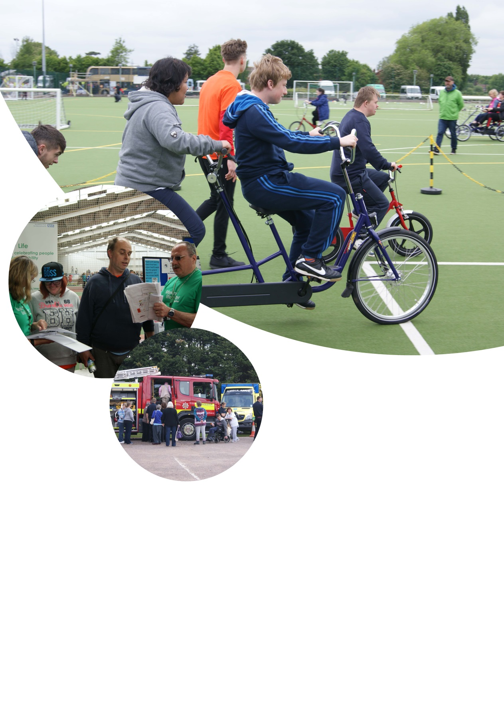

**How to contact the Learning Disability Health Facilitation Team**

**Learning Disabilities**



**Freephone:** 0800 019 3346

**Telephone:** 01452 321015

**Text:** 0776 673 3421



**Health Facilitation Team**

Ambrose House

Units 4 & 5

Meteor Court

Barnett Way

Barnwood

Gloucester

GL4 3GG



For more information about 2gether NHS Foundation Trust

go to www.2gether.nhs.uk

**The Learning Disability**

**Health Facilitation Team**

If you want more copies or want this leaflet in another format, please contact the Communications Team at 2gether NHS Foundation Trust, Rikenel, Montpellier, Gloucester, GL1 1LY. You can email us at 2gnft.comms@nhs.net

Mental & Social Healthcare HealthFacilitation_002

Review date: October 2017

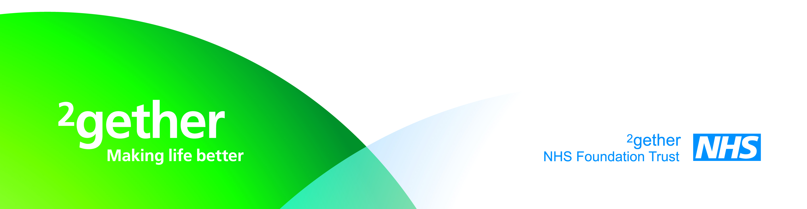

Health Facilitation _ 002

Review Date June 2018

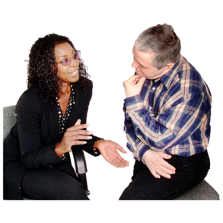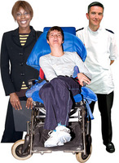

Our target: People with learning disabilities will get excellent care.

We work with people with learning disabilities and their carers

We help people speak up about their health.

We support them to manage their own needs.

**Our Vision/Target**

**7**

**2**

Notes

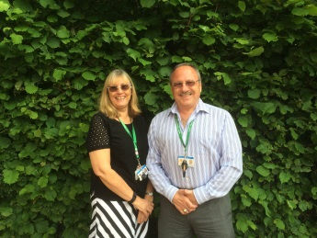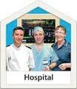

We help health workers to understand your needs

We help hospitals, GP’s and other teams to be easier to use.

We can help you and your carers to get the health information you need.

Community Learning Disability Team (CLDT)

**3**

**6**

Emergency Contact

Social Worker

Name………………………………………….

…………………………………………

Name………………………………………….

…………………………………………

Doctor

Name………………………………………….

…………………………………………

Name………………………………………….

…………………………………………

**Who can you talk to:**

**“How can we help you” first**

**How we can help services and teams:**

**Training**

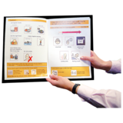

We can help with your Health Action Plan.

We train people like doctors, nurses and dentists.

We help them to understand your needs.





We can support you to take control of your health.

We can help you to be healthier and happier



We train people who help someone with a learning disability.

We teach them about health so they can support people.



We can give advice to you and anyone that helps you.

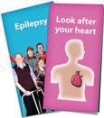

We help people to find easy read information.

**5**

**4**