Quality Report 2017/18

CONTENTS
Part 1 |  | Statement on Quality from the Chief Executive |  | 3
 |  | Introduction |  | 3
Part 2.1 |  | Looking ahead to 2018/19 |  | 3
 |  | Priorities for Improvement 2017/18 |  | 3
Part 2.2 |  | Statements relating to the Quality of the NHS Services Provided |  | 3
 |  | Review of services |  | 3
 |  | Participation in Clinical Audits and National Confidential Enquiries |  | 3
 |  | Participation in Clinical Research |  | 3
 |  | Use of the CQUIN payment framework |  | 4
 |  | Statements from the Care Quality Commission |  | 6
 |  | Quality of Data |  | 7
Part 2.3 |  | Mandated Core Indicators for 2017/18 |  | 8
Part 3 |  | Looking Back: A review of Quality in 2017/18 |  | 12
 |  | Introduction  Summary |  | 12  12
 |  | Easy Read Summary |  | 13
 |  | Effectiveness: |  | 15
 |  | User Experience: |  | 20
 |  | Safety: |  | 24
 |  | Serious Incidents |  | 30
 |  | Duty of Candour |  | 31
 |  | Mortality Reviews |  | 31
 |  | NHS improvement Indicators & Thresholds for 2017/18 |  | 32
 |  | Community Survey 2017 |  | 33
 |  | Staff Survey 2017 |  | 33
 |  | PLACE Assessment Results 2017/18 |  | 33
Annex 1 | Statements from our partners on the Quality Report |  | 33
Annex 2 | Statement of Directors’ Responsibilities in respect of the Quality Report |  | 33
Annex 3 | Glossary |  | 33
Annex 4 | How to Contact Us |  | 36
 | About this report |  | 36
 | Other Comments, Concerns, Complaints and Compliments |  | 36
 | Alternative Formats |  | 36

Part 1: Statement on Quality from the Chief Executive

Introduction

This will be included at year-end

Part 2.1: Looking ahead to 2018/19

Quality Priorities for Improvement 2018/19

These will be developed during Quarter 4 under the following domains.

Effectiveness

User Experience

Safety

Part 2.2: Statements relating to the Quality of NHS Services Provided

Review of Services

This will be included at year-end

Participation in Clinical Audits and National Confidential Enquiries

This will be included at year-end

Participation in Clinical Research

This will be included at year-end

Use of the Commissioning for Quality & Innovation (CQUIN) framework

A proportion of ²gether NHS Foundation Trust’s income in 2016/17 was conditional on achieving quality improvement and innovation goals agreed between ²gether NHS Foundation Trust and any person or body they entered into a contract, agreement or arrangement with for the provision of relevant health services, through the Commissioning for Quality and Innovation payment framework. Further details of the agreed goals for 2017/18 and for the following 12 month period are available electronically at http://www.2gether.nhs.uk/cquin

2017/18 CQUIN Goals

Gloucestershire

Gloucestershire  Goal Name | Description | Goal weighting | Expected value |  | Quality Domain
1a (a) National CQUIN – Staff health and wellbeing | To achieve a 5 percentage point improvement in 2 of the 3 NHS annual staff survey questions on Health and Wellbeing | 0.3 |  | £72261 |  | Effectiveness
1b National CQUIN – Staff health and wellbeing | Healthy food for NHS staff, visitors and patients |  |  | £72261 |  | Effectiveness
1c National CQUIN - Staff health and wellbeing | Improving the uptake of flu vaccinations for front line staff |  |  | £72261 |  | Safety
2 National CQUIN -Improving Physical Healthcare 3a | - To reduce premature mortality by demonstrating cardio metabolic assessment and treatment for patients with psychoses. | 0.3 |  | £173426 |  | Effectiveness
2 National CQUIN -Improving Physical Healthcare 3b | - To reduce premature mortality  - Improved communication with GPs |  |  | £43357 |  | Effectiveness
3. Improving Services for people with mental health needs who present to A & E. | Care and management for frequent attenders to Accident and Emergency | 0.3 |  | £216783 |  | Safety
4. Transitions out of Children and Young People’s Mental Health Services. | To improve the experience and outcomes for young people as they transition out of (CYPMHS) | 0.3 |  | £216783 |  | Effectiveness
5.Preventing ill health by risky behaviours – Alcohol and Tobacco | To offer advice and interventions aimed at reducing risky behaviour in admitted patients | 0.3 |  | £216783 |  | Effectiveness

Herefordshire

Herefordshire  Goal Name | Description | Goal weighting | Expected value | Quality Domain
1a (a) National CQUIN – Staff health and wellbeing | To achieve a 5 percentage point improvement in 2 of the 3 NHS annual staff survey questions on Health and Wellbeing | 0.3 | £17231 | Effectiveness
1b National CQUIN – Staff health and wellbeing | Healthy food for NHS staff, visitors and patients |  | £17231 | Effectiveness
1c National CQUIN - Staff health and wellbeing | Improving the uptake of flu vaccinations for front line staff |  | £17231 | Safety
2 National CQUIN -Improving Physical Healthcare 3a | - To reduce premature mortality by demonstrating cardio metabolic assessment and treatment for patients with psychoses. | 0.3 | £41354 | Effectiveness
2 National CQUIN -Improving Physical Healthcare 3b | - To reduce premature mortality  - Improved communication with GPs |  | £10339 | Effectiveness
3. Improving Services for people with mental health needs who present to A & E. | Care and management for frequent attenders to Accident and Emergency | 0.3 | £51693 | Safety
4. Transitions out of Children and Young People’s Mental Health Services. | To improve the experience and outcomes for young people as they transition out of (CYPMHS) | 0.3 | £51693 | Effectiveness
5.Preventing ill health by risky behaviours – Alcohol and Tobacco | To offer advice and interventions aimed at reducing risky behaviour in admitted patients | 0.3 | £51693 | Effectiveness

Low Secure Services

Low Secure  Goal Name | Description | Goal weighting | Expected value | Quality Domain
Reduction in length of stay | Aim to reduce lengths of stay of inpatient episodes and to optimise the care pathway. Providers to plan for discharge at the point of admission and to ensure mechanisms are in place to oversee the care pathway against estimated discharge dates. | 2.5 | £45000 | Effectiveness

The total potential value of the income conditional on reaching the targets within the CQUINs during 2016/17 is £2,219,300 of which we anticipate £2,219,300 will be achieved.

In 2015/16, the total potential value of the income conditional on reaching the targets within the CQUINs was £2,107,995 of which £2,107,153 was achieved.

2018/19 CQUIN Goals

These will be added at year-end.

Statements from the Care Quality Commission

The Care Quality Commission (CQC) is the independent regulator of health and adult social care services in England. From April 2010, all NHS trusts have been legally required to register with the CQC. Registration is the licence to operate and to be registered, providers must, by law, demonstrate compliance with the requirements of the CQC (Registration) Regulations 2009.

²gether NHS Foundation Trust is required to register with the Care Quality Commission and its current registration status is to provide the following regulated activities:
- Assessment or medical treatment to persons detained under the Mental Health act 1983;
- Diagnostic and screening procedures;
- Treatment of disease, disorder or injury.

²gether NHS Foundation Trust has no conditions on its registration.

The CQC has not taken enforcement action against ²gether NHS Foundation during 2016/17 or the previous year 2015/16.

CQC Inspections of our services

²gether NHS Foundation Trust has not participated in any special reviews or investigations by the CQC during the reporting period.

The Care Quality Commission last undertook a planned comprehensive inspection of the Trust week commencing 26 October 2015 and published its findings on 28 January 2016. The CQC rated our services as GOOD, rating 2 of the 10 core services as “outstanding” overall and 6 “good” overall.

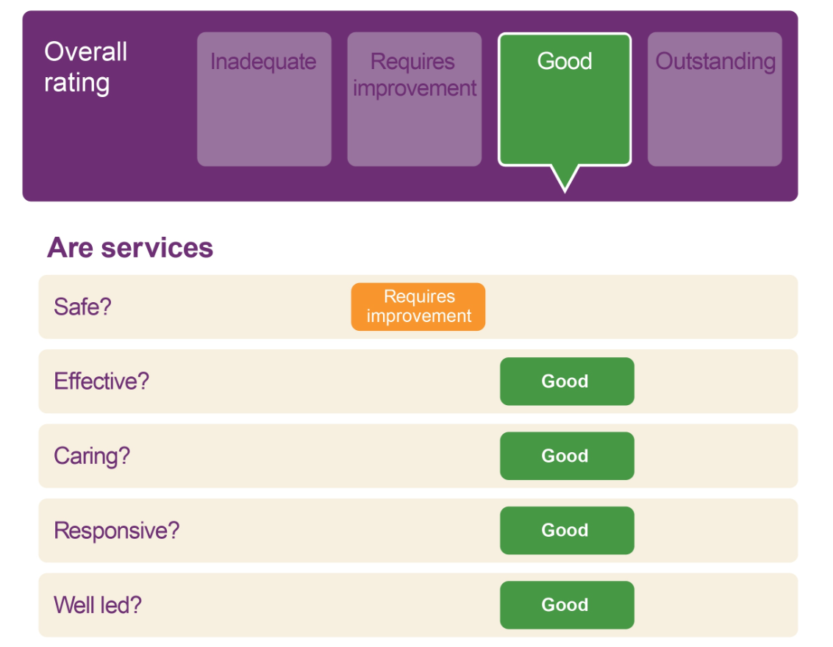

The inspection found that there were some aspects of care and treatment in some services that needed improvements to be made to ensure patients were kept safe. However, the vast majority of services were delivering effective care and treatment.

The Trust developed an action plan in response to the 15 “must do” recommendations, and the 58 “should do” recommendations identified by the inspection and is managing the actions through to their completion.

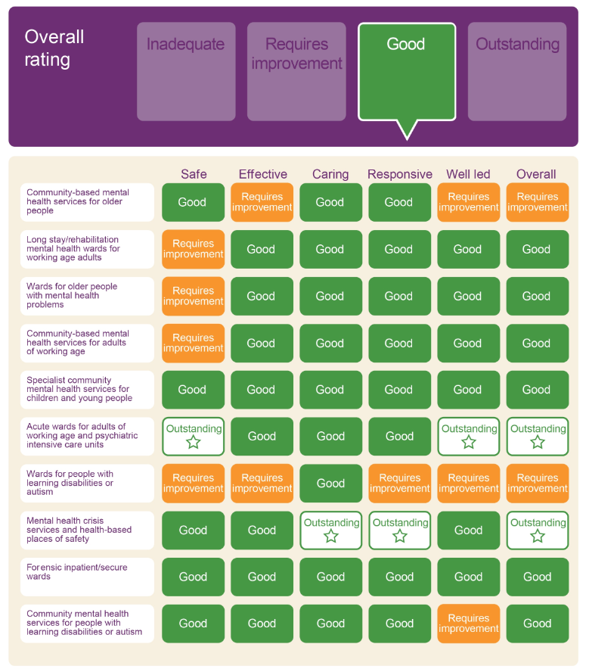

A full copy of the Comprehensive Inspection Report can be seen here.

Changes in service registration with Care Quality Commission for 2017/18

This will be included at year-end.

Quality of Data

This will be included at year-end.

Part 2.3: Mandated Core Indicators 2017/18
There are a number of mandated Quality Indicators which organisations providing mental health services are required to report on, and these are detailed below. The comparisons with the national average and both the lowest and highest performing trusts are benchmarked against other mental health service providers.

- Percentage of patients on CPA who were followed up within 7 days after discharge from psychiatric inpatient care

 | Quarter 1  2016-17 | Quarter 2  2016-17 | Quarter 3  2016-17 | Quarter 4  2016-17 | Quarter 1*  2017-18
²gether NHS Foundation Trust | 97.1% | 97.2% | 98.3% | 99.2% | 99.2%
National Average | 96.2% | 96.8% | 96.8% | 96.8% | 96.7%
Lowest Trust | 28.6% | 76.9% | 73.3% | 84.6% | 71.4%
Highest Trust | 100% | 100% | 100% | 99.4% | 100%

The ²gether NHS Foundation Trust considers that this data is as described for the following reasons:
- During 2015/16 we reviewed our practices and policies associated with both our 7 day and 48 hour follow up of patients discharged from our inpatient services, the changes were introduced in 2016/17. This has strengthened the patient safety aspects of our follow up contacts.

The ²gether NHS Foundation Trust has taken the following action to improve this percentage, and so the quality of its services, by:

- Clearly documenting follow up arrangements from Day 1 post discharge in RiO;
- Continuing to ensure that service users are followed up within 48 hours of discharge from an inpatient unit whenever possible.

- Proportion of admissions to psychiatric inpatient care that were gate kept by Crisis Teams
 | Quarter 1  2016-17 | Quarter 2  2016-17 | Quarter 3  2016-17 | Quarter 4  2016-17 | Quarter 1*  2017-18
²gether NHS Foundation Trust | 98.9% | 98.9% | 99.4% | 100% | 100%
National Average | 98.1% | 98.4% | 98.7% | 98.8% | 98.7%
Lowest Trust | 78.9% | 76% | 88.3% | 90% | 88.9%
Highest Trust | 100% | 100% | 100% | 100% | 100%

The ²gether NHS Foundation Trust considers that this data is as described for the following reasons:
- Staff respond to individual service user need and help to support them at home wherever possible unless admission is clearly indicated;

The ²gether NHS Foundation Trust has taken the following action to improve this percentage, and so the quality of its services, by:

- Continuing to remind clinicians who input information into the clinical system (RiO) to both complete the ‘Method of Admission’ field with the appropriate option when admissions are made via the Crisis Team and ensure that all clinical interventions are recorded appropriately in RiO within the client diary.

* Activity published on NHS England website via the NHS IC Portal is revised throughout the year following data quality checks. Activity shown for Quarter 1 2017/18 has not yet been revised and may change. Quarter 2 data has not been published.

- The percentage of patients aged 0-15 & 16 and over, readmitted to hospital, which forms part of the Trust, within 28 days of being discharged from a hospital which forms part of the trust, during the reporting period
 | Quarter 1  2016-17 | Quarter 2  2016-17 | Quarter 3  2016-17 | Quarter 4  2016-17 | Quarter 1  2017-18
²gether NHS Foundation Trust 0-15 | 0% | 0% | 0% | 0% | 0%
²gether NHS Foundation Trust 16 + | 7% | 5% | 8% | 6% | 6.3%
National Average | Not available | Not available | Not available | Not available | Not available
Lowest Trust | Not available | Not available | Not available | Not available | Not available
Highest Trust | Not available | Not available | Not available | Not available | Not available

The ²gether NHS Foundation Trust considers that this data is as described for the following reasons:
- The Trust does not have child and adolescent inpatient beds;
- Service users with serious mental illness are readmitted hospital to maximize their safety and promote recovery;
- Service users on Community Treatment Orders (CTOs) can recalled to hospital if there is deterioration in their presentation.

The ²gether NHS Foundation Trust has taken the following action to improve this percentage, and so the quality of its services, by:

- Continuing to promote a recovery model for people in contact with services;
- Supporting people at home wherever possible by the Crisis Resolution and Home Treatment Teams.

- The percentage of staff employed by, or under contract to, the Trust during the reporting period who would recommend the Trust as a provider of care to their family or friends

 | NHS Staff Survey 2013 | NHS Staff Survey 2014 | NHS Staff Survey 2015 | NHS Staff Survey 2016
²gether NHS Foundation Trust Score | 3.46 | 3.61 | 3.75 | 3.84
National Median Score | 3.55 | 3.57 | 3.63 | 3.62
Lowest Trust Score | 3.01 | 3.01 | 3.11 | 3.20
Highest Trust Score | 4.04 | 4.15 | 4.04 | 3.96

The ²gether NHS Foundation Trust considers that this data is as described for the following reasons:

- For the first time, all staff in post on 1 September 2016 were invited to take part in the survey, confidentially online. Previously the survey had only been sent to a random sample of 750 staff. The overall response rate was 40%, equal to the previous year but 777 staff took the time to respond and give their views, a significant increase on the 298 responses in the previous year. The 2016 survey has provided the most accurate picture of the Trust obtained to-date.

- Staff have reported an increase in the level of motivation at work. Whilst the improved level of staff satisfaction is encouraging, the trust is very careful to also take note of feedback from colleagues who are less satisfied and where possible to address these concerns.

The ²gether NHS Foundation Trust has taken the following actions to improve this score and so the quality of its services, by:

- Encouraging staff to report any incidents which affect patient and staff safety or morale in the workplace;
- Acting to make the best use of service user feedback and highlighting how this feedback is used;
- Promoting the health and wellbeing of Trust staff.

- “Patient experience of community mental health services” indicator score with regard to a patient’s experience of contact with a health or social care worker during the reporting period.

 | NHS Community Mental Health Survey 2013 | NHS Community Mental Health Survey 2014 | NHS Community Mental Health Survey 2015 | NHS Community Mental Health Survey 2016
²gether NHS Foundation Trust Score | 8.7 | 8.2 | 7.9 | 8.0
National Average Score | Not available | Not available | Not available | Not available
Lowest Score | 8.0 | 7.3 | 6.8 | 6.9
Highest Score | 9.0 | 8.4 | 8.2 | 8.1

The ²gether NHS Foundation Trust considers that this data is as described for the following reasons:
- Across six of the ten domains in the survey our scores were reported as ‘About the Same’ as other trusts. In the other four domains people scored ²gether’s service as ‘Better than Others’, which is in the top 20% of similar organisations.

The ²gether NHS Foundation Trust has taken the following actions to improve this score and so the quality of its services, by:
- Helping people with a focus on their physical health needs;
- Providing people with signposting, support and advice on finances and benefits;
- Help people with finding support for gaining or keeping employment;
- Signposting and supporting people to take part in activities of interest;
- Helping people to access peer support from others with experience of the same mental health needs;
- Ensure knowledge of contacts in time of crisis;
- Provision of information about new medicines.

- The number and rate* of patient safety incidents reported within the Trust during the reporting period and the number and percentage of such patient safety incidents that resulted in severe harm or death.

 | 1 April 2016 – 30 September 2016 |  |  |  |  | 1 October 2016 – 31 March 2017
 | Number | Rate* | Severe |  | Death | Number | Rate* | Severe | Death
²gether NHS Foundation Trust | 1,900 | 54.85 | 4 | 30 |  | 2,474 | 72.05 | 2 | 17
National | 162,954 | - | 562 | 1240 |  | 157,141 | - | 538 | 1233
Lowest Trust | 40 | 10.28 | 0 | 0 |  | 68 | 11.17 | 0 | 0
Highest Trust | 6,349 | 88.97 | 50 | 84 |  | 6,447 | 88.21 | 72 | 100
* Rate is the number of incidents reported per 1000 bed days.

The ²gether NHS Foundation Trust considers that this data is as described for the following reasons:
- NRLS data is published 6 months in arrears; therefore data for severe harm and death will not correspond with the serious incident information shown in the Quality Report.

The ²gether NHS Foundation Trust has taken the following action to improve this rate, and so the quality of its services, by:

- Re-auditing its Incident Reporting Systems (DATIX) to improve the processes in place for the timely review, approval of, and response to reported patient safety incidents;

- Creating an additional part time DATIX Administrator post to enhance data quality checks and further promote timeliness of reporting. This post commenced in 2017/18.

Part 3: Looking Back: A Review of Quality during 2016/17

Introduction
The 2017/18 quality priorities were agreed in May 2017.

The quality priorities were grouped under the three areas of Effectiveness, User Experience and Safety.

The table below provides a summary of our progress against these individual priorities. Each are subsequently explained in more detail throughout Part 3.

Summary Report on Quality Measures for 2016/2017

 |  | 2016 - 2017 | 2017 -2018
Effectiveness
1.1 | To improve the physical health of patients with a serious mental illness on CPA by a positive cardio metabolic health resource (Lester Tool). This will be used on all patients who meet the criteria within the inpatient setting and all community mental health teams. In accordance with national CQUIN targets we aim to achieve 90% compliance for inpatients and early intervention teams and 65% compliance for all other community mental health teams. | Achieved | Achieved
1.2 | To further improve personalised discharge care planning in adult and older peoples wards, including the provision of discharge information to primary care services within 24hrs of discharge. | Achieved | Not achieved
1.3 | To ensure that joint Care Programme Approach reviews occur for all service users who make the transition from children’s to adult services. | Not achieved | Achieved
User Experience
2.1 | Were you involved as much as you wanted to be in agreeing what care you will receive? > 92% | 83% | 88%
2.2 | Do you know who to contact out of office hours if you have a crisis? >74% | 74% | 86%
2.3 | Has someone given you advice about taking part in activities that are important to you? > 69% | 69% | 89%
2.4 | Have you had help and advice to find support to meet your physical health needs if you needed it? > 76% | 76% | 89%
Safety
3.1 | Reduce the proportion of patients in touch with services who die by suspected suicide when compared with data from previous years. This will be expressed as a rate per 1000 service users on the Trust’s caseload. | - | Achieved
3.2 | Detained service users who are absent without leave (AWOL) will not come to serious harm or death.  We will report against 3 categories of AWOL as follows; harm as a consequence of:  - Absconded from escort  - Failure to return from leave  - Left the hospital (escaped) | - | Achieved
3.3 | To reduce the number of prone restraints by 5% year on year (on all adult wards & PICU) based on 2016/17 data. | 211 | 134

Easy Read Report on Quality Measures for 2017/2018

Quality Report | This report looks at the quality of ²gether’s services.  We agreed with our Commissioners the areas that would be looked at.
Physical health | We increased physical health tests and treatment for people using our services.  We met the target.
Discharge Care Plans | Less people had all parts of their discharge care plan completed at the end of the quarter than previously.
Care (CPA) Review | Everyone moving from children’s to adult services had a care review.  We met the target.
Care Plans | 82% of people said they felt involved in their care plan.  This is less than the target (92%).  We have not met the target.  We are doing lots of work to get better at this.
Crisis | 88% of people said they know who to contact if they have a crisis.  This is more than the target (74%).  We met the target.
Activity | 81% of people said they had advice about taking part in activities.  This is more than the target (69%).  We met the target.
Physical Health  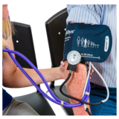 | 79% of people said they had advice about their physical health  This is more than the target (76%).  We met the target.

Suicide | There have been less suicides compared to this time last year.  We have met the target.  We are working hard to keep people safe.
AWOL  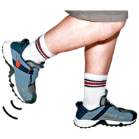 | Inpatients who were absent without leave did not come to serious harm or death.  We met the target.
Face down restraint  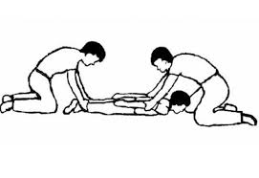 | We have not reduced the number of face-down restraints this year.  We have not met the target.  We are doing lots of work to get better at this.

Key

 |  |  | Full assurance
↑ | Increased performance/activity |  | Significant assurance
↔ | Performance/activity remains similar |  | Limited assurance
↓ | Reduced performance/activity |  | Negative assurance

Effectiveness

In 2017/18 we remained committed to ensure that our services are as effective as possible for the people that we support. For the second consecutive year we set ourselves 3 targets against the goals of:

  - Improving the physical health care for people with schizophrenia and other serious mental illnesses;
  - Ensuring that people are discharged from hospital with personalised care plans;
  - Improving transition processes for child and young people who move into adult mental health services.

Target 1.1 To increase the number of service users (all inpatients and all SMI/CPA service users in the community, inclusive of Early Intervention Service, Assertive Outreach and Recovery) with a LESTER tool intervention (a specialist cardio metabolic assessment tool) alongside increased access to physical health treatment

A two year Physical Health CQUIN was announced for 2017/19. This CQUIN includes all service users with an active diagnosis of psychosis (using the CQUIN specified ICD-10 codes) who were either an inpatient or who had accessed community services including; Assertive Outreach Team (AOT), Recovery Teams, Community Learning Disability Teams (CLDT’s), Older Age Services (OP’s) and Children and Young Persons Services (CYPS). The sample group has now been extended to include service users from both counties.

Following on from the Lester Tool training and implementation for staff in quarter one, the Trust has been able to provide ongoing support from the physical health facilitators. The cardio metabolic health screening is now embedded in practice for community and inpatient service users, local compliance audits are encouraging.

The quarter two target looked at collaboration with primary care clinicians with an aim to improve the flow of useful clinical information between secondary and primary care. The Trust was asked to identify and develop clear plans for aligning and cross checking SMI QOF and CPA registers.

We have identified key leads within both Herefordshire and Gloucestershire CCG’s to help with this liaison. We are working closely with them to provide us with guidance on our next steps.

Within Herefordshire, we will aim to email all Practice Managers to raise the profile of the purpose of cross referencing the SMI QOF with CPA registers. This will be the first stage of creating links with primary care to facilitate this information sharing opportunity. We have liaised with Taurus Healthcare in order to gain support and understanding for the rationale of this CQUIN, and how we anticipate this will improve patient care and collaboration between primary and secondary care.

Within Gloucestershire the CCG’s Locality Development and Primary Care Directorate has kindly offered to email all Practice Managers to raise the profile of the purpose of cross referencing the SMI QOF with CPA registers. This will be the first stage of creating links with primary care to facilitate this information sharing opportunity.

Alongside the CQUIN work, the Trust continues to increase access to physical health treatment for its’ service users. Following the successful secondment of a general trained nurse working within the inpatient units in Gloucestershire, the matron is planning to advertise a substantive position for this role to continue. This will ensure patients to access services normally only available from a practice nurse at a GP surgery.

In April 2017 the Trust became “Smoke-Free”, and the benefit of this to both staff and service users continues to be evident. The Trust plans to hold a “Smoke free” event for the South West in February 2018.

We are currently meeting this target.

Target 1.2 To further improve personalised discharge care planning in adult and older peoples wards, including the provision of discharge information to primary care services within 24hrs of discharge.

Discharge from inpatient units to the community can pose a time of increased risk to service users. During 2016/17 we focused on making improvements to discharge care planning to ensure that service users are actively involved in shared decision making for their discharge and the self-management care planning process. Identical criteria are being used in the services across both counties as follows:

- Has a Risk Summary been completed?
- Has the Clustering Assessment and Allocation been completed?
- Has the Pre-Discharge Planning Form been completed?
- Have the inpatient care plans been closed within 7 days of discharge?
- Has the patient been discharged from the bed?
- Has the Nursing Discharge Summary Letter to Client/GP been sent within 24 hours of discharge?
- Has the 48 hour follow up been completed?

We will also be looking to ensure that discharges summaries and medication information for service users discharged from hospital are sent to their GP within 48 hours of Discharge.

We are also including discharge care planning information from within our Recovery Units, as they too discharge people back into the community.

Results from the quarterly audit against these standards are seen below.

Gloucestershire Services

Criterion | Year End Compliance (2015/16) | Year End Compliance  (2016/17) | Quarter 1 Compliance  (2017/18) | Quarter 1 Compliance  (2017/18)
Overall Average Compliance | 69% | 72% | 73% | 71%
Chestnut Ward | 84% | 85% | 81% | 87%
Mulberry Ward | 75% | 79% | 73% | 76%
Willow Ward | 59% | 71% | 69% | 65%
Abbey Ward | 72% | 75% | 78% | 83%
Dean Ward | 79% | 73% | 69% | 71%
Greyfriars PICU | 50% | 62% | 62% | 59%
Kingsholm Ward | 75% | 72% | 69% | 74%
Priory Ward | 80% | 80% | 87% | 76%
Montpellier Unit | 50% | 57% | 67% | 50%
Honeybourne | N/A | 70% | 70% | 60%
Laurel House | N/A | 65% | 75% | 80%

* Data for Honeybourne and Laurel House (Recovery Units) was not collected in 2015/16 – only hospital wards were audited to reflect comparable data across both Gloucestershire and Herefordshire.

Quarter 2 overall average compliance in Gloucester for these standards during this year is 71% which is a 2% reduction from the end of Quarter 1, it is noted that several inpatient areas have reduced in this area. There will be an increased focus on ensuring that these standards are met throughout the year.

Herefordshire Services

Criterion | Year End compliance (2015/16) | Year End Compliance  2016/17) | Quarter 1 Compliance  (2017/18) | Quarter 2 Compliance  (2017/18)
Overall Average Compliance | N/A | 74% | 70% | 66%
Cantilupe Ward | N/A | 85% | 78% | 77%
Jenny Lind Ward | N/A | 71% | 71% | 62%
Mortimer Ward | N/A | 69% | 64% | 58%
Oak House | N/A | 70% | 67% | 67%

Quarter 2 overall average compliance in Herefordshire for these standards during this year is 66% which is a 4% reduction from the end of Quarter 2 , noting that three of the inpatient areas have further reduced in this area. There will be an increased focus on ensuring that these standards are met throughout the year.

Trustwide compliance for each of the individual criteria assessed is outlined in the table below. For future audits, services will focus on the criteria scoring an AMBER or RED RAG rating to promote improvement.

 |  | %
1. | Has a Risk Summary been completed? | 100%
2. | Has the Clustering Assessment and Allocation been completed? | 81%
3. | Has the Pre-Discharge Planning Form been completed? | 32%
4. | Have the inpatient care plans been closed within 7 days of discharge? | 21%
5. | Has the patient been discharged from bed? | 100%
6. | Has the Nursing Discharge Summary Letter to Client/GP been sent within 24 hours of discharge? | 79%
7. | Has the 48 hour follow up been completed if the Community Team are not doing it? | 93%

This target has not been met.

Target 1.3 To ensure that joint Care Programme Approach reviews occur for all service users who make the transition from children’s to adult services.

The period of transition from children and young people’s services (CYPS) to adult mental health services is often daunting for both the young person involved and their family or carers. We want to ensure that this experience is as positive as it can be by undertaking joint Care Programme Approach (CPA) reviews between children’s and adult services every time a young person transitions to adult services.

Results from 2016-17 transitions are also included below so that historical comparative information is available.

Gloucestershire Services

2016-17 Results

Criterion | Compliance  Quarter 1 (2016/17) | Compliance  Quarter 2 (2016/17) | Compliance  Quarter 3 (2016/17) | Compliance  Quarter 4  (2016/17)
Joint CPA Review | 86% | 100% | 100% | N/A

2017-18 Results

During Quarter 2, there were 2 young people who transitioned into adult services, they had a joint CPA review.

Criterion | Compliance  Quarter 1 (2017/18) | Compliance  Quarter 2 (2017/18) | Compliance  Quarter 3 (2017/18) | Compliance  Quarter 4  (2017/18)
Joint CPA Review | 100% | 100%

Herefordshire Services

2016-17 Results

Criterion | Compliance  Quarter 1 2016/17) | Compliance  Quarter 2 (2016/17) | Compliance  Quarter 3 (2016/17) | Compliance  Quarter 4  (2016/17)
Joint CPA Review | 33% | 50% | 100% | 100%

2017-18 Results

Criterion | Compliance  Quarter 1 (2017/18) | Compliance  Quarter 2 (2017/18) | Compliance  Quarter 3 (2017/18) | Compliance  Quarter 4  (2017/18)
Joint CPA Review | 100% | 100%

During Quarter 2, there were 2 transitions of young people into adult services, all of these had a joint CPA review.

To improve our practice and documentation in relation to this target, a number of measures were developed during 2016-17 as follows:

- Transition to adult services for any young person will be included as a standard agenda item for teams, to provide the opportunity to discuss transition cases;
- Transition will be included as a standard agenda item in caseload management to identify emerging cases;
- Teams are encouraged to contact adult mental health services to discuss potential referrals;
- There is a data base which identifies cases for transition;
- SharePoint report identifies those young people who are 17.5 years open to CYPS. Team Managers will monitor those who are coming up to transition and discuss in supervision.

We are currently meeting this target.

User Experience

In this domain, we have set ourselves 1 goal of improving service user experience and carer experience with 4 associated targets.

- Improving the experience of service users in key areas. This was measured though defined survey questions for both people in community and inpatient settings.
The Trust’s How did we do? survey combines the NHS Friends and Family Test and the Quality Survey. The Quality Survey questions encourage people to provide feedback on key aspects of their care and treatment.

The two elements of the How did we do? survey will continue to be reported separately as Friends and Family Test and Quality Survey responses by county. A combined total percentage for both counties is also provided to mirror the methodology used by the CQC Community Mental Health Survey.

Data for Quality Survey (Quarter 1 - July to September 2017) results:

Target 2.1 Were you involved as much as you wanted to be in agreeing the care you will receive? > 92%

Question | County | Number of responses | Target Met?
Were you involved as much as you wanted to be in agreeing the care you receive? | Gloucestershire | 28 (22 positive) | 88%  TARGET 92%
 | Herefordshire | 50 (47 positive)
 | Total | 78 (69 positive)

This target has not been met but response rates and outcomes have improved compared to Quarter 1 (82%).

Target 2.2 Have you been given information about who to contact outside of office hours if you have a crisis? > 74%

Question | County | Number of responses | Target Met?
Have you been given information about who to contact outside of office hours if you have a crisis? | Gloucestershire | 27 (20 positive) | 86%  TARGET 74%
 | Herefordshire | 50 (46 positive)
 | Total | 77 (66 positive)

This target has been met.

Target 2.3 Have you had help and advice about taking part in activities that are important to you? >69%

Question | County | Number of responses | Target Met?
Have you had help and advice about taking part in activities that are important to you? | Gloucestershire | 26 (20 positive) | 89%  TARGET 69%
 | Herefordshire | 47 (43 positive)
 | Total | 73 (63 positive)

This target has been met.

Target 2.4 Have you had help and advice to find support for physical health needs if you have needed it? > 76%

Question | County | Number of responses | Target Met?
Have you had help and advice to find support for physical health needs if you have needed it? | Gloucestershire | 24 (21 positive) | 89%  TARGET 76%
 | Herefordshire | 39 (35 positive)
 | Total | 63 (56 positive)

This target has been met.

Quality survey targets were reviewed and refreshed in line with the launch of the How did we do? Survey. Three out of the four targets set have been exceeded. This is positive and suggests that, of those people who responded to the survey, most are feeling supported to meet their needs and explore other activities.

The one target that has not been fully achieved (Target 2.1) continues to receive a high percentage of positive responses. It is important to acknowledge that this target for 2016/17 was 78% and that this was consistently exceeded during this time. The increase in the target set for 2017/18 is demonstrative of our desire to consistently improve our services and although the target has not yet been met, the responses are more positive than the previous quarter

Friends and Family Test (FFT)

FFT responses and scores for Quarter 2

The FFT involves service users being asked “How likely are you to recommend our service to your friends and family if they needed similar care or treatment?”

Our Trust played a key role in the development of an Easy Read version of the FFT. Roll out of this version ensures that everybody is supported to provide feedback.

The table below details the number of combined total responses received by the Trust each month in quarter 2. The FFT score is the percentage of people who stated that they would be ‘extremely likely’ or ‘likely’ to recommend our services. These figures are submitted for national reporting.

 | Number of responses | FFT Score (%)
July 2017 | 152 (137 positive) | 90%
August 2017 | 134 (117 positive) | 87%
September 2017 | 337 (308 positive) | 91%
Total | 623 (562 positive)  (last quarter = 617) | 90%  (last quarter = 90%)

The Quarter 2 response rates are slightly higher than the previous quarter. This is encouraging news, it is expected that this increase will continue as the new system continues to be embedded along with the planned introduction of SMS surveys in Quarter 3 2017/18.

The FFT score for Quarter 2 has remained consistent with that received in 2016/17.The Trust continues to maintain a high percentage of people who would recommend our services.

FFT Scores for ²gether NHS Foundation Trust for the past year. The following graph shows the FFT Scores for the past rolling year, including this quarter. The Trust receives consistently positive feedback.
Figure 1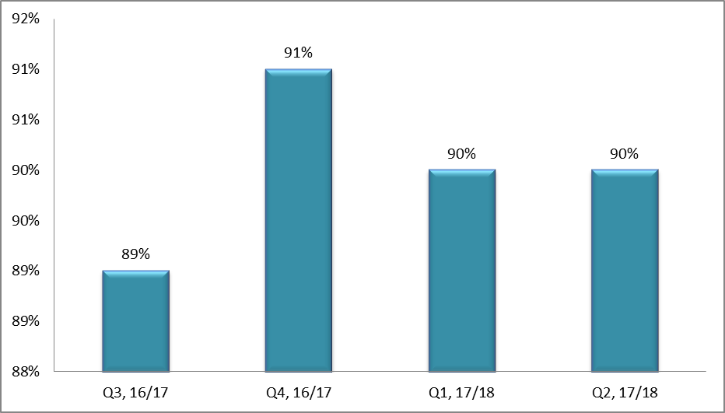
The FFT score for Quarter 2 has remained consistent with previous quarters. The Trust continues to maintain a high percentage of people who would recommend our services.

Friends and Family Test Scores – comparison between ²gether Trust and other Mental Health Trusts across England

The chart below shows the FFT scores for June, July, and August 2017 (the most recent data available) compared to other Mental Health Trusts in our region and the national average. Our Trust consistently receives a high percentage of recommendation in line with other Mental Health Trusts in the region (September 2017 data is not yet available).
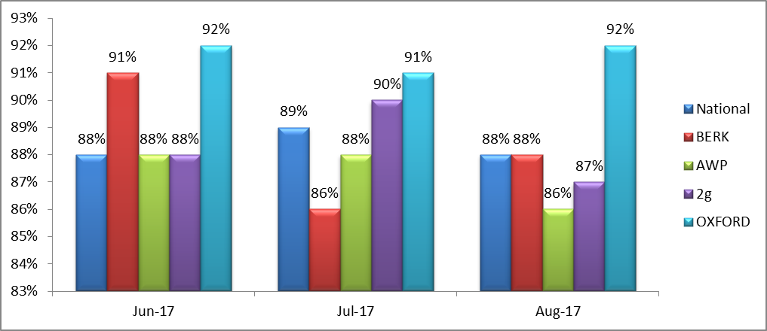
2g – 2gether NHS Foundation Trust // AWP – Avon and Wiltshire Mental Health Partnership NHS Trust
BERK – Berkshire Healthcare NHS Foundation Trust // OXFORD – Oxford Health NHS Foundation Trust

Safety

Protecting service users from further harm whilst they are in our care is a fundamental requirement. We seek to ensure that we assess the safety of those who use our services as well as providing a safe environment for service users, staff and everyone else that comes into contact with us. In this domain, we have set ourselves 3 goals to:

- Minimise the risk of suicide of people who use our services;
- Ensure the safety of people detained under the Mental Health Act;
- Reduce the number of prone restraints used in our adult inpatient services:

There are 3 associated targets.

Target 3.1 Reduce the proportion of patients in touch with services who die by suspected suicide when compared with data from previous years. This will be expressed as a rate per 1000 service users on the Trust’s caseload.

We aim to minimise the risk of suicide amongst those with mental disorders through systematic implementation of sound risk management principles. In 2013/14, during which year we reported 22 suspected suicides, we set ourselves a specific quality target for there to be fewer deaths by suicide of patients in contact with teams and we have continued with this important target each year. Sadly the number increased and during 2016/17 we reported 26 suspected suicides. At the end of Quarter 2 2017/18 the number of reported suspected suicides was 14, 3 less than at the end of the same quarter last year. This is seen in Figure 4.

Figure 4

What we also know is that we are seeing more and more service users on our caseload year on year, so we are going measure this important target differently this year. This will be as reported as a rate per 1000 service users on the Trust caseload. The graph in Figure 5 shows this rate from 2014/15 onwards for all Trust services covering Herefordshire and Gloucestershire, and we are aiming to see the median value (green line) get smaller. During both 2015/16 and 2016/17 the median value was 0.09. At the end of Quarter 2 2017/18, the median value remains at 0.09.

Figure 4

In terms of the inquest conclusions, these are shown in Figure 6 below. It is seen that the majority of reported suspected suicides are determined as such by the Coroner.

Figure 6

We are currently meeting this target.

Target 3.2 Detained service users who are absent without leave (AWOL) will not come to serious harm or death.

Much work has been done to understand the context in which detained service users are absent without leave (AWOL) via the NHS South of England Patient Safety and Quality Improvement Mental Health Collaborative. AWOL reporting includes those service users who:

- Abscond from a ward,
- Do not return from a period of agreed leave,
- Abscond from an escort.

In 2015/16 we reported 114 occurrences of AWOL (83 in Gloucestershire and 31 in Herefordshire. Last year we reported 211 occurrences of AWOL (162 in Gloucestershire and 49 in Herefordshire) so there has been a considerable increase in the numbers of people who are AWOL year on year. There are a number of factors which influence this, including open wards, increased numbers of detained patients in our inpatient units, increased acuity, and on occasion, service users who leave the hospital without permission multiple times.

What we want to ensure is that no service users who are AWOL come to serious harm or death, so this year we are measuring the level of harm that people come to when absent. The charts below show the levels of harm from our reported AWOLs for each year from 2015/16 onwards.

Figure 7

Figure 8

Figure 9

We are meeting this target.

Target 3.3 To reduce the number of prone restraints by 5% year on year (on all adult wards & PICU)

During 2015/16, the Trust developed an action plan to reduce the use of restrictive interventions, in line with the 2 year strategy – Positive & Safe: developed from the guidance Positive and Proactive Care: reducing the need for restrictive interventions. This strategy offered clarity on what models and practice need to be undertaken to support sustainable reduction in harm and restrictive approaches, with guidance and leadership by the Trust Board and a nominated lead.

The Trust developed its own Positive & Safe Sub-Committee during 2015/16 which is a sub–committee of the Governance Committee. The role of this body is to:

- Support the reduction of all forms of restrictive practice;
- Promote an organisational culture that is committed to developing therapeutic environments where physical interventions are a last resort;
- Ensure organisational compliance with the revised Mental Health Act 1983 Code of Practice (2015) and NICE Guidance for Violence and Aggression;
- Oversee and assure a robust training programme and assurance system for both Prevention & Management of Violence & Aggression (PMVA) and Positive Behaviour Management (PBM);
- Develop and inform incident reporting systems to improve data quality and reliability;
- Improve transparency of reporting, management and governance;
- Lead on the development and introduction of a Trust wide RiO Physical Intervention Care Plan/Positive Behavioural Support.

As use of prone restraint (face down) is sometimes necessary to manage and contain escalating violent behaviour, it is also the response most likely to cause harm to an individual. Therefore, we want to minimise the use of this wherever possible through effective engagement and occupation in the inpatient environment. All instances of prone restraint are recorded and this information was used to establish a baseline in 2015/16. Overall, there were 121 occasions when prone restraint was used in our acute adult wards and PICU.

At the end of 2016/17, 211 instances of prone restraint were used as seen in Figure 8 which was an overall increase.

Figure 10

In terms of further developments to minimise the use of prone restraint, injection sites for the purpose of rapid tranquillisation have been reviewed. Historically, staff have been trained to provide rapid tranquillisation intramuscularly via the gluteal muscles, this necessitates the patient being placed into the prone restraint position if they are resistant to the intervention. New training is in the process of being rolled out to all inpatient nursing and medical staff to be able to inject via the quadriceps muscles. This requires the patient to be placed in the supine position which poses less risk. These important changes are being implemented during 2017/18 and it is anticipated that we will ultimately see a corresponding reduction in the use of prone restraint.

At the end of Quarter 1, 80 instances of prone restraint were used which saw a further increase, however, 54 prone restraints were reported in Quarter 2 which is 26 occurrences less than the previous quarter.

Figure 11

We have not yet met this target.

Serious Incidents reported during 2017/18

By the end of Quarter 2 2017/18, 28 serious incidents were reported by the Trust, 3 of which were subsequently declassified; the types of these incidents reported are seen below in Figure 10.

Figure 10

Figure 11 shows a 4 year comparison of reported serious incidents. The most frequently reported serious incidents are “suspected suicide” and attempted suicide which is why we continue to focus on suicide prevention activities in partnership with stakeholders. All serious incidents were investigated by senior members of staff, all of whom have been trained in root cause analysis techniques. To further improve consistency of our serious incident investigations we have seconded a whole time equivalent Lead Investigator for 12 months who commenced this important work in May 2017, and a further dedicated Investigating Officer is now available via the Trust’s Staff Bank. This arrangement will be reviewed during Quarter 4 2017/18.

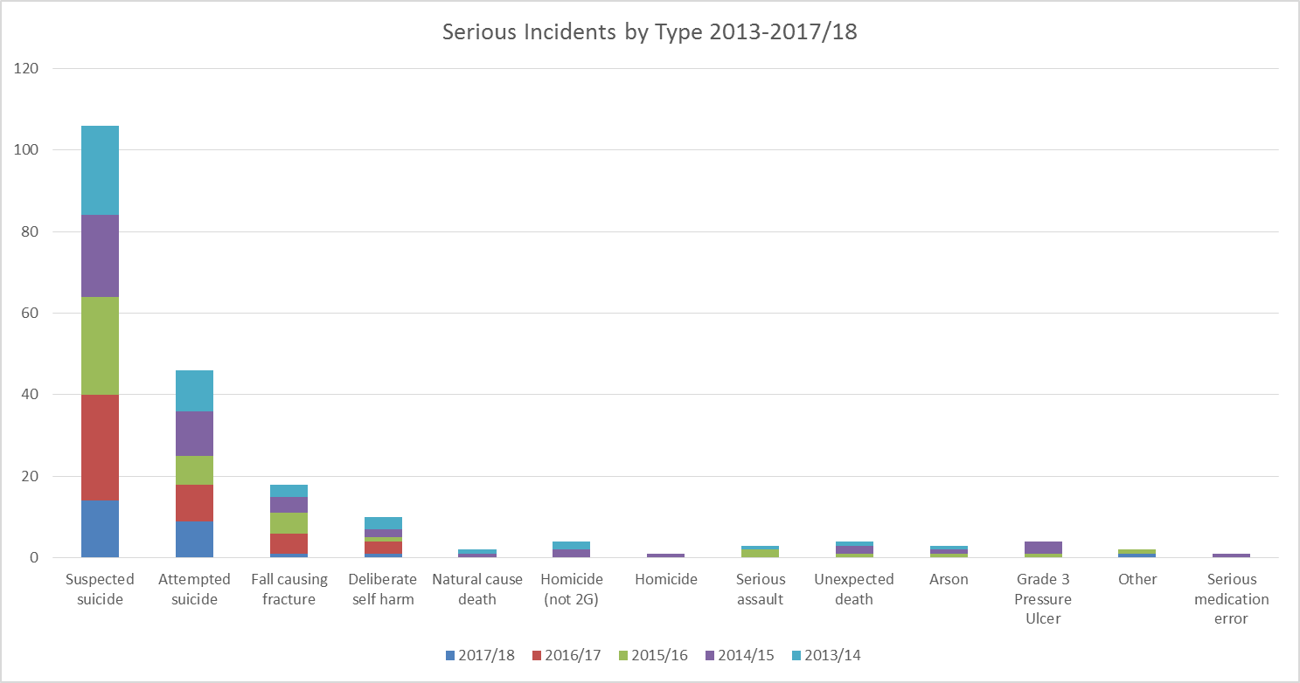
Figure 11

Wherever possible, we include service users and their families/carers to ensure that their views are central to the investigation, we then provide feedback to them on conclusion. During 2016/17 we engaged the Hundred Families organisation to deliver ‘Making Families Count’ training to 51 staff to improve our involvement of families and this will be explored further next year. During 2017/18 we will also be developing processes to provide improved support to people bereaved by suicide. The Trust shares copies of our investigation reports regarding “suspected suicides” with the Coroners in both Herefordshire and Gloucestershire to assist with the Coronial investigations.

There have been no Department of Health defined “Never Events” within the Trust during 2017/18. Never Events are serious, largely preventable patient safety incidents that should not occur if the available preventative measures have been implemented.

Duty of Candour

The Duty of Candour is a statutory regulation to ensure that providers of healthcare are open and honest with services users when things go wrong with their care and treatment. The Duty of Candour was one of the recommendations made by Robert Francis to help ensure that NHS organisations report and investigate incidents (that have led to moderate harm or death) properly and ensure that service users are told about this.

The Duty of Candour is considered in all our serious incident investigations, and as indicated in our section above regarding serious incidents, we include service users and their families/carers in this process to ensure their perspective is taken into account, and we provide feedback to them on conclusion of an investigation. Additionally, we review all reported incidents in our Datix System (incident reporting system) to ensure that any incidents of moderate harm or death are identified and appropriately investigated.

To support staff in understanding the Duty of Candour, we have historically provided training sessions through our Quality Forums and given all staff leaflets regarding this. There is also a poster regarding this on every staff notice board.

During the CQC comprehensive inspection of our services, they reviewed how the Duty of Candour was being implemented across the Trust and provided the following comments in their report dated 27 January 2016.

“Staff across the trust understood the importance of being candid when things went wrong including the need to explain errors, apologise to patients and to keep patients informed.”

“We saw how duty of candour considerations had been incorporated into relevant processes such as the serious investigation framework and complaints procedures. Staff across the trust were aware of the duty of candour requirements in relation to their role.”

Our upgraded Incident Reporting System (Datix) has been configured to ensure that any incidents graded moderate or above are flagged to the relevant senior manager/clinician, who in turn can investigate the incident and identify if the Duty of Candour has been triggered. Only the designated senior manager/clinician can “sign off” these incidents.

Mortality Reviews

From 1 April 2016 the Trust has collected detailed information regarding the deaths of patients open to our services, and deaths within 6 months of their discharge from services in preparation for the “Single Framework for Reviewing Deaths in the NHS” requirement which was published in March 2017. To date, there is limited assurance that the data collected is of good quality. However, several improvements have been made to both Datix and the technology available for collecting information relating to patient deaths.

An administrator has been employed in a full-time capacity from October 2016 to begin to complete initial screening of the reported patient death information and the categorisation of patient deaths within the Mazars categories of Expected Natural 1, Expected Natural 2, Expected Unnatural, Unexpected Natural 1, Unexpected Natural 2, and Unexpected Unnatural. The pro-forma review tool based on the Learning Disabilities Mortality Review Programme (LeDer) format will be utilised within the Datix system to assist with desktop reviews of healthcare records, and red flag indicators are being developed by the Clinical Directors involved with the mortality work to identify deaths which should be more closely investigated.

The ‘active’ review of patient information commenced from 1 April 2017 and our ‘Learning from Deaths Policy’ was approved by the Board and published in September 2017 in line with the requirements of the “National Guidance on Learning from Deaths”. We will be publishing our mortality review data by Quarter 3 2017/18.

Sign up to Safety Campaign – Listen, Learn and Act (SUP2S)

²gether NHS Foundation Trust signed up to this campaign from the outset and was one of the first 12 organisations to do so. Within the Trust the campaign is being used as an umbrella under which to sit all patient safety initiatives such as the NHS South of England Patient Safety and Quality Improvement Mental Health Collaborative, the NHS Safety Thermometer, Safewards interventions and the Reducing Physical Interventions project. Participation in SUP2S webinars has occurred, and webinar recordings are shared with colleagues. A Safety Improvement Plan has been developed, submitted and approved. Monitoring of progress as a whole is completed every 6 months via the Trust Governance Committee, but each work stream has its own regular forum and reporting mechanisms.

Indicators & Thresholds for 2017/2018

The following table shows the metrics that were monitored by the Trust during 2016/17. These are the indicators and thresholds from NHS Improvement.

 |  | 2015-2016  Actual | 2016-2017  Actual | National  Threshold | 2017-2018  Actual
1 | Clostridium Difficile objective | 0 | 3 | 0 | 0
2 | MRSA bacteraemia objective | 0 | 0 | 0 | 0
3 | 7 day CPA follow-up after discharge | 95.63% | 98% | 95% | 99%
4 | CPA formal review within 12 months | 99.35% | 99% | 95% | 97%
5 | Delayed transfer of care | 1.02% | 1.7% | ≤7.5% | 0.7%
6 | Admissions gate kept by Crisis resolution/home treatment services | 99.74% | 99% | 95% | 100%
7 | Serving new psychosis cases by early intervention teams | 63.56% | 71% | 50% | 74%
8 | MHMDS data completeness: identifiers | 99.57% | 99.9% | 97% | 99.9%
9 | MHMDS data completeness: CPA outcomes | 97.42% | 94.7% | 50% | 94.6%
10 | Learning Disability – six criteria | 6 | 6 | 6 | 6
11 | EIP: Receipt of NICE approved care within 2 weeks | - | 71.3% | 50% | tbc
12 | Improving access to psychological therapies
 | - treated within 6 weeks of referral |  | 37.8% | 75% | 58%
 | - treated within 18 weeks of referral |  |  | 95% | 86%

Commissioner Agreed Developments

This will be included at year-end.

Community Survey 2016

This will be included at year-end.

Staff Survey 2016

This will be included at year-end.

PLACE Assessment 2016

This will be included at year-end.

Annex 1: Statements from our partners on the Quality Report

This will be included at year-end.

The Royal College of Psychiatrists

This will be included at year-end.

Annex 2: Statement of Directors’ Responsibilities in respect of the Quality Report

This will be included at year-end.

Annex 3: Glossary

ADHD  BMI | Attention Deficit Hyperactivity Disorder  Body Mass Index
CAMHS | Child & Adolescent Mental Health Services
CBT | Cognitive Behavioural Therapy
CCG  CHD | Clinical Commissioning Group  Coronary Heart Disease
CPA | Care Programme Approach: a system of delivering community service to those with mental illness
CQC | Care Quality Commission – the Government body that regulates the quality of services from all providers of NHS care.
CQUIN  CYPS  DATIX | Commissioning for Quality & Innovation: this is a way of incentivising NHS organisations by making part of their payments dependent on achieving specific quality goals and targets  Children and Young Peoples Service  This is the risk management software the Trust uses to report and analyse incidents, complaints and claims as well as documenting the risk register.
GriP | Gloucestershire Recovery in Psychosis (GriP) is ²gether’s specialist early intervention team working with people aged 14-35 who have first episode psychosis.
HoNOS | Health of the Nation Outcome Scales – this is the most widely used routine  Measure of clinical outcome used by English mental health services.
IAPT | Improving Access to Psychological Therapies
Information Governance (IG) Toolkit  MCA | The IG Toolkit is an online system that allows NHS organisations and partners to assess themselves against a list of 45 Department of Health Information Governance policies and standards.  Mental Capacity Act
MHMDS | The Mental Health Minimum Data Set is a series of key personal information that should be recorded on the records of every service user
Monitor | Monitor is the independent regulator of NHS foundation trusts.  They are independent of central government and directly accountable to Parliament.
MRSA  MUST | Methicillin-resistant Staphylococcus aureus (MRSA) is a bacterium responsible for several difficult-to-treat infections in humans. It is also called multidrug-resistant  The Malnutrition Universal Screening Tool is a five-step screening tool to identify adults, who are malnourished, at risk of malnutrition (undernutrition), or obese. It also includes management guidelines which can be used to develop a care plan.
NHS | The National Health Service refers to one or more of the four publicly funded healthcare systems within the United Kingdom. The systems are primarily funded through general taxation rather than requiring private insurance payments. The services provide a comprehensive range of health services, the vast majority of which are free at the point of use for residents of the United Kingdom.
NICE | The National Institute for Health and Care Excellence (previously National Institute for Health and Clinical Excellence) is an independent organisation responsible for providing national guidance on promoting good health and preventing and treating ill health.
NIHR | The National Institute for Health Research supports a health research system in which the NHS supports outstanding individuals, working in world class facilities, conducting leading edge research focused on the needs of patients and the public.
NPSA  PBM  PHSO | The National Patient Safety Agency is a body that leads and contributes to improved, safe patient care by informing, supporting and influencing the health sector.  Positive Behaviour Management  Parliamentary Health Service Ombudsman
PICU  PLACE  PROM  PMVA | Psychiatric Intensive Care Unit  Patient-Led Assessments of the Care Environment  Patient Reported Outcome Measures (PROMs) assess the quality of care delivered to NHS patients from the patient perspective.  Prevention and Management of Violence and Aggression
RiO  ROMs | This is the name of the electronic system for recording service user care notes and related information within ²gether NHS Foundation Trust.  Routine Outcome Monitoring (ROMs)
SIRI  SMI | Serious Incident Requiring Investigation, previously known as a “Serious Untoward Incident”. A serious incident is essentially an incident that occurred resulting in serious harm, avoidable death, abuse or serious damage to the reputation of the trust or NHS. In the context of the Quality Report, we use the standard definition of a Serious Incident given by the NPSA  Serious mental illness
VTE | Venous thromboembolism is a potentially fatal condition caused when a blood clot (thrombus) forms in a vein. In certain circumstances it is known as Deep Vein Thrombosis.

Annex 4: How to Contact Us

About this report

If you have any questions or comments concerning the contents of this report or have any other questions about the Trust and how it operates, please write to:

Mr Shaun Clee
Chief Executive Officer
²gether NHS Foundation Trust
Rikenel
Montpellier
Gloucester
GL1 1LY

Or email him at: shaun.clee@nhs.net

Alternatively, you may telephone on 01452 894000 or fax on 01452 894001.

Other Comments, Concerns, Complaints and Compliments
Your views and suggestions are important us. They help us to improve the services we provide.
You can give us feedback about our services by:
- Speaking to a member of staff directly
- Telephoning us on 01452 894673
- Completing our Online Feedback Form at www.2gether.nhs.uk
- Completing our Comment, Concern, Complaint, Compliment Leaflet, available from any of our Trust sites or from our website www.2gether.nhs.uk
- Using one of the feedback screens at selected Trust sites
- Contacting the Patient Advice and Liaison Service (PALS) Advisor on 01452 894072
- Writing to the appropriate service manager or the Trust’s Chief Executive

Alternative Formats

If you would like a copy of this report in large print, Braille, audio cassette tape or another language, please telephone us on 01452 894000 or fax on 01452 894001.

